Recent Color Photographs (exterior)

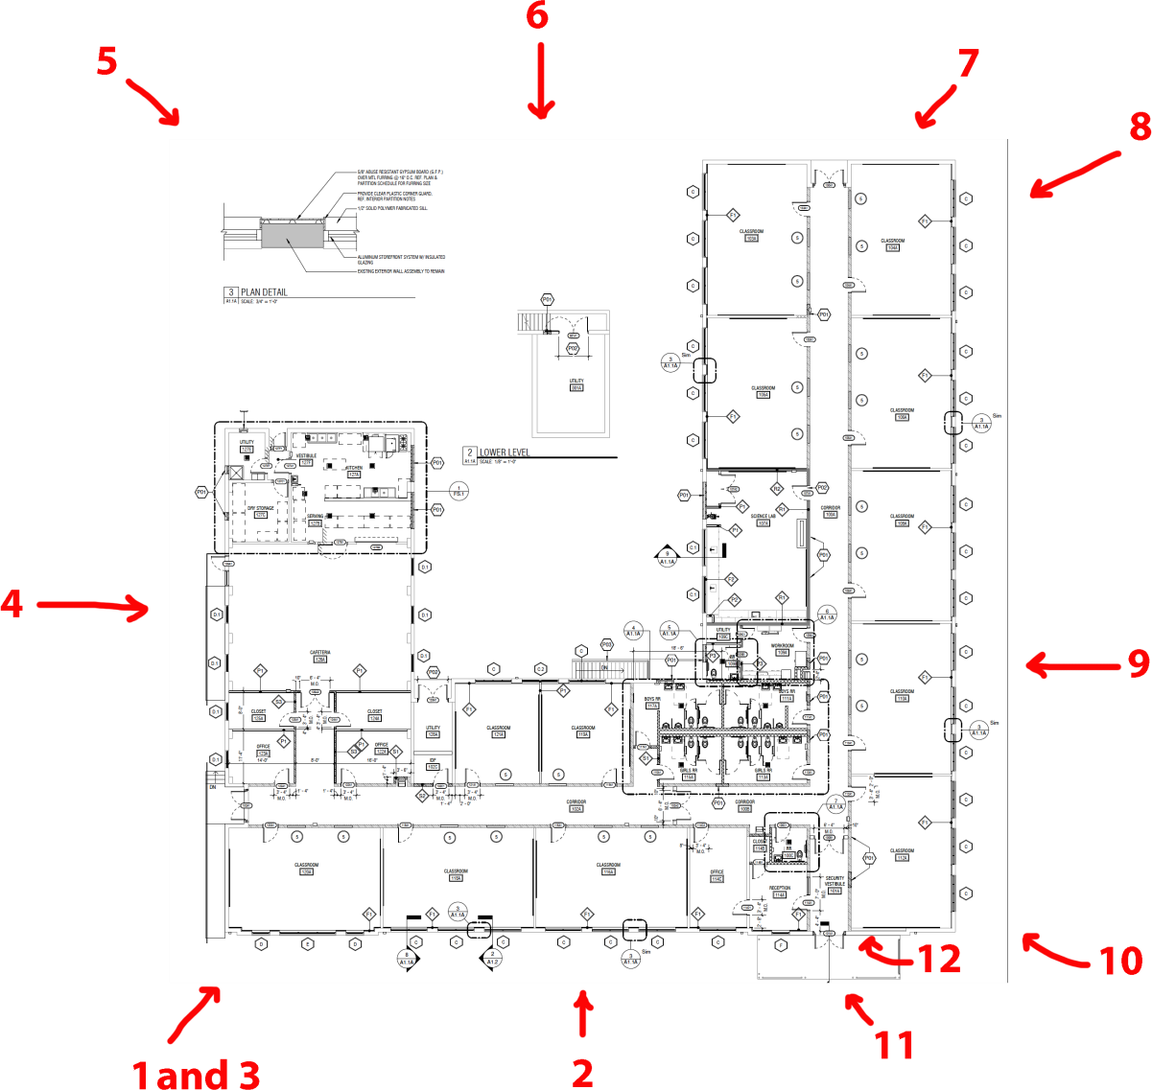

2019 (before)
1 – View from northeast
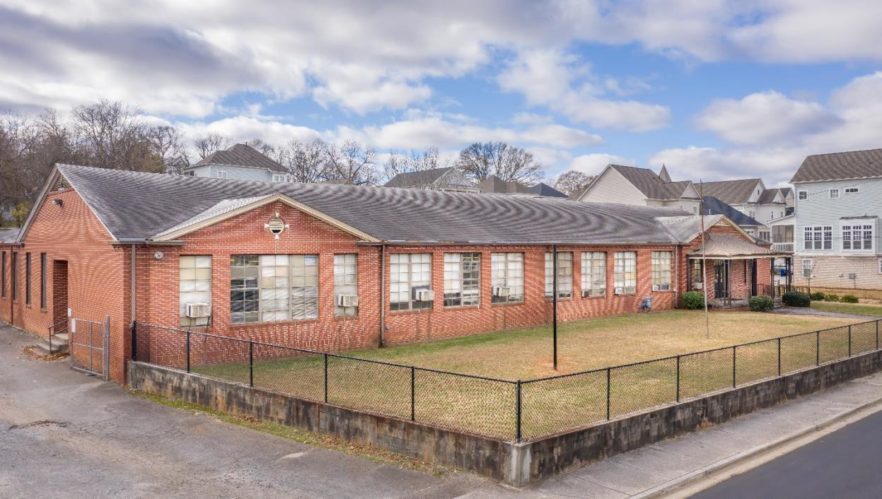
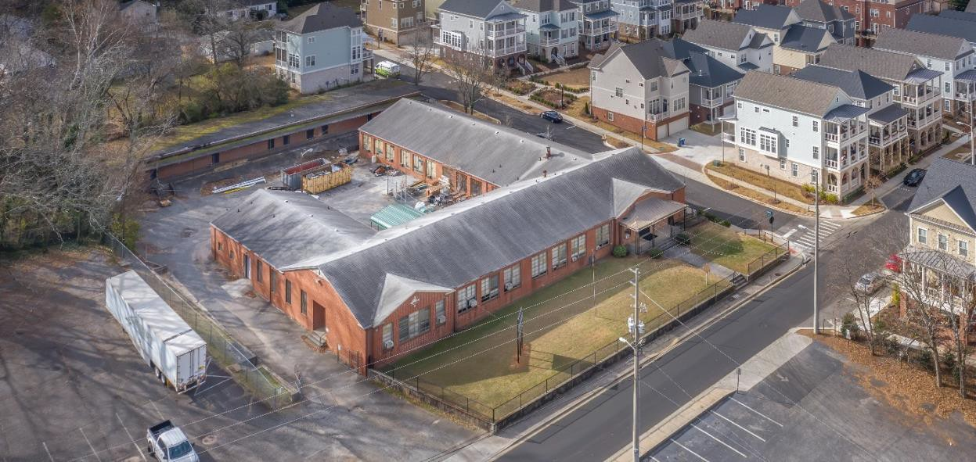

2021 (after)
2 – View from north
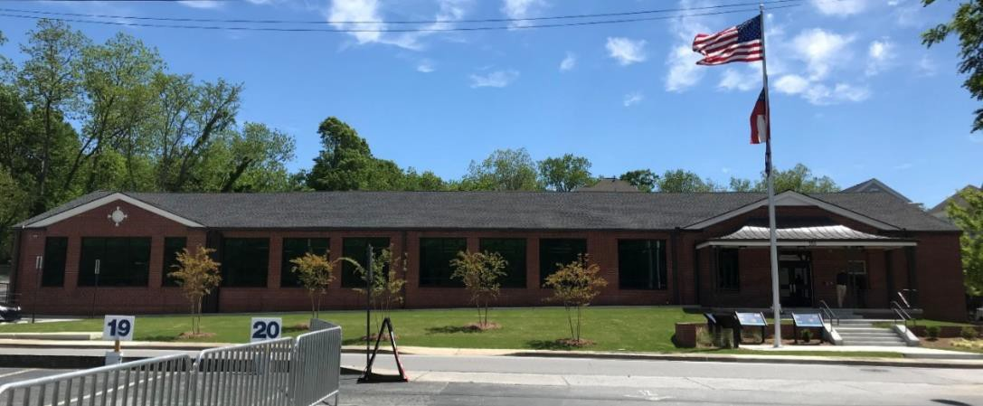
3 – View from northeast
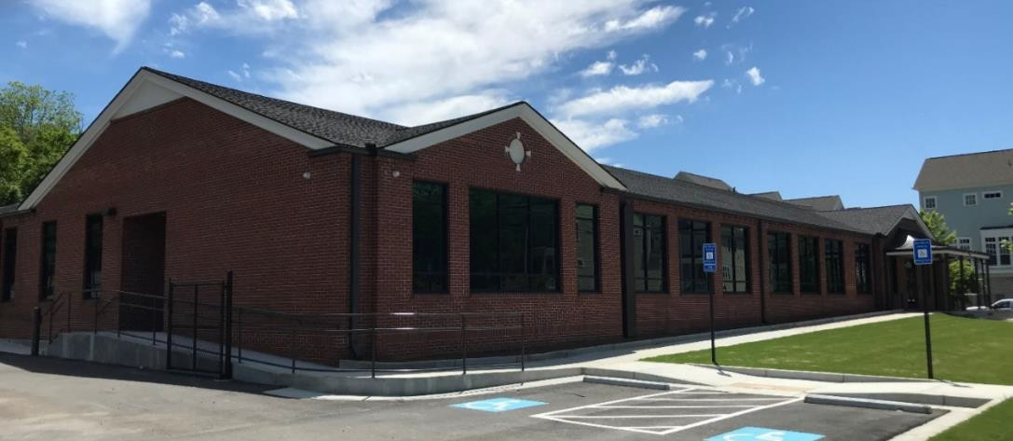
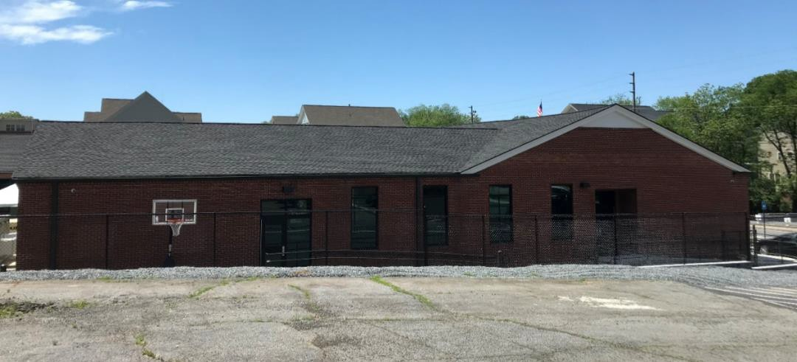
4 – View from east

5 – View from southeast
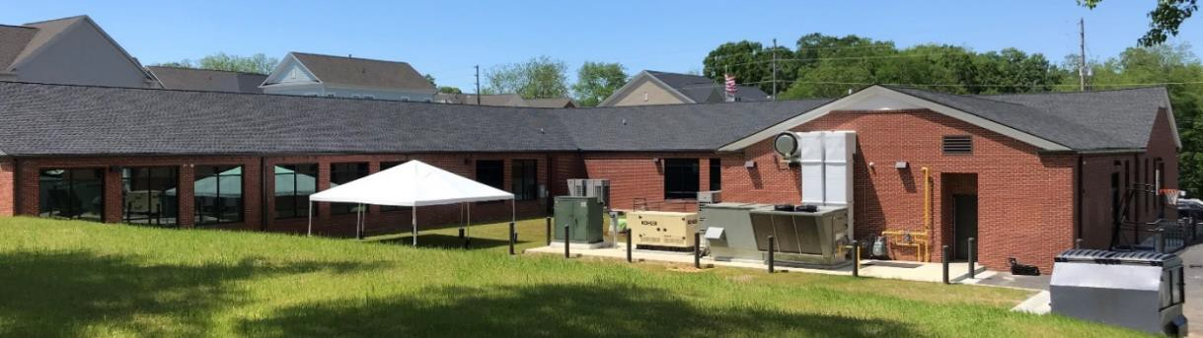
6 – View from south
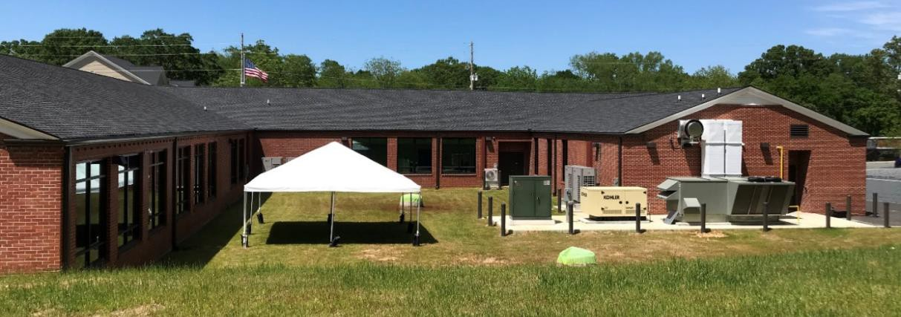
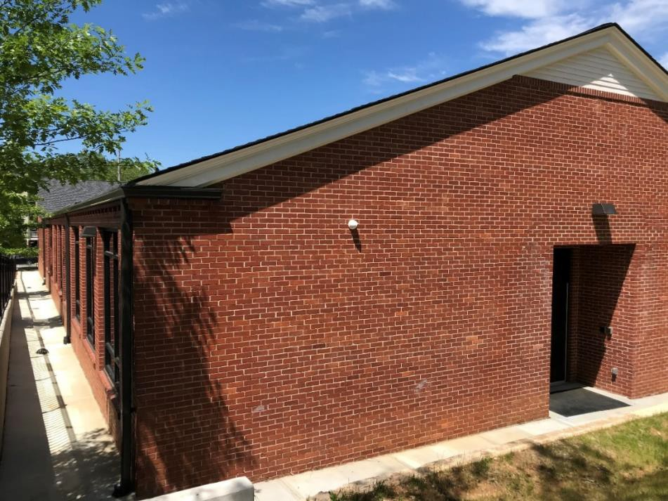
- – View from southwest

- – View from southwest
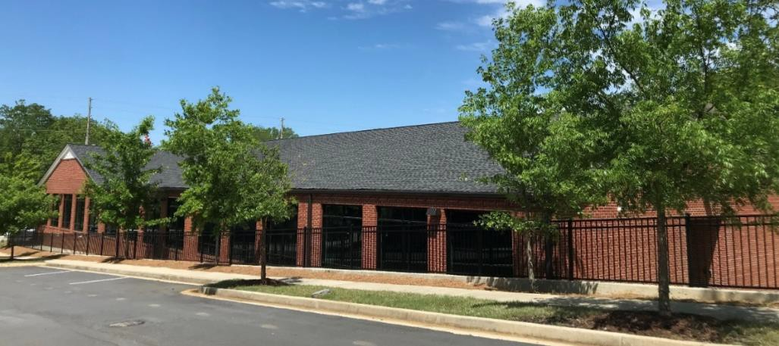
- – View from west
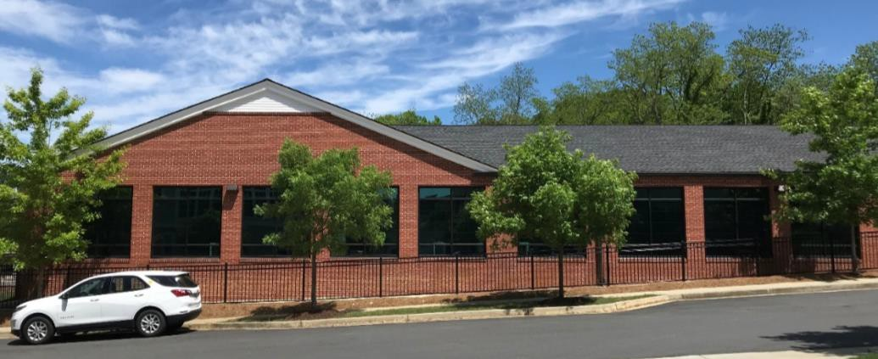
- – View from west
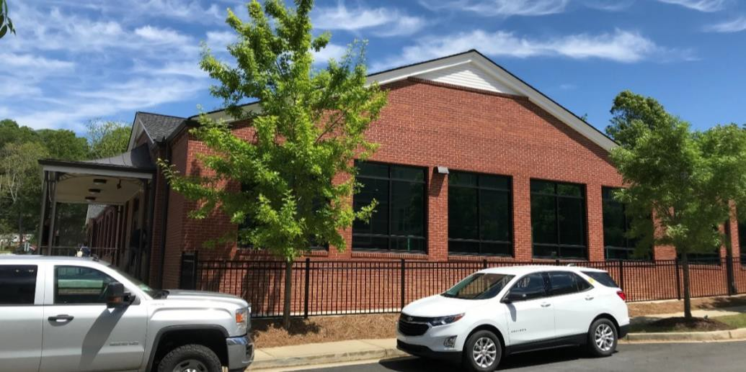

- – View from northwest
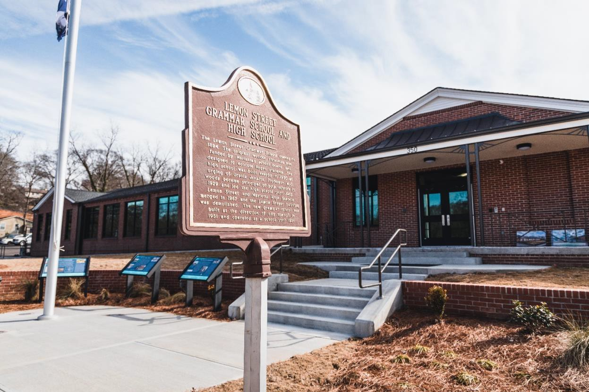
- – Dedication plaques (1951 and 2021)
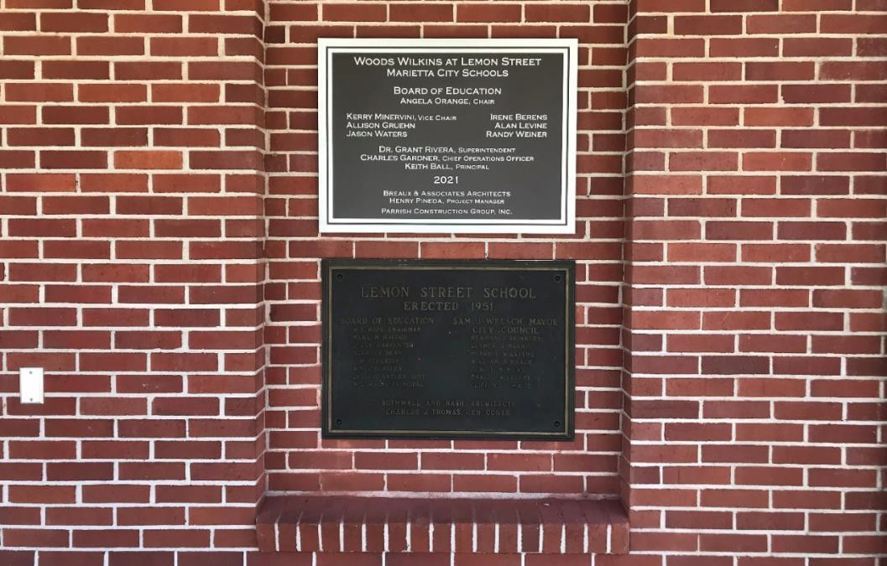

Recent Color Photographs (interior)

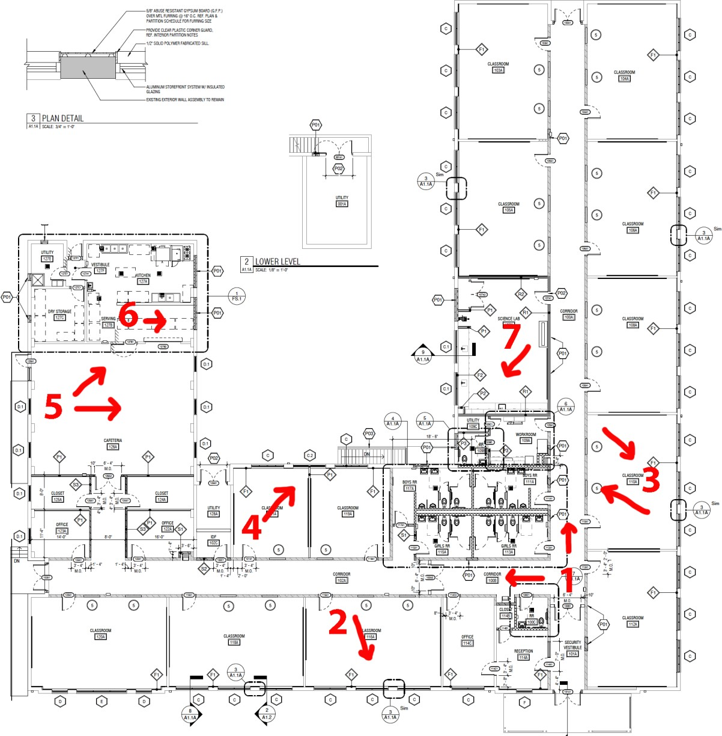

1 – East (left) and south-facing views of hallway (2019)
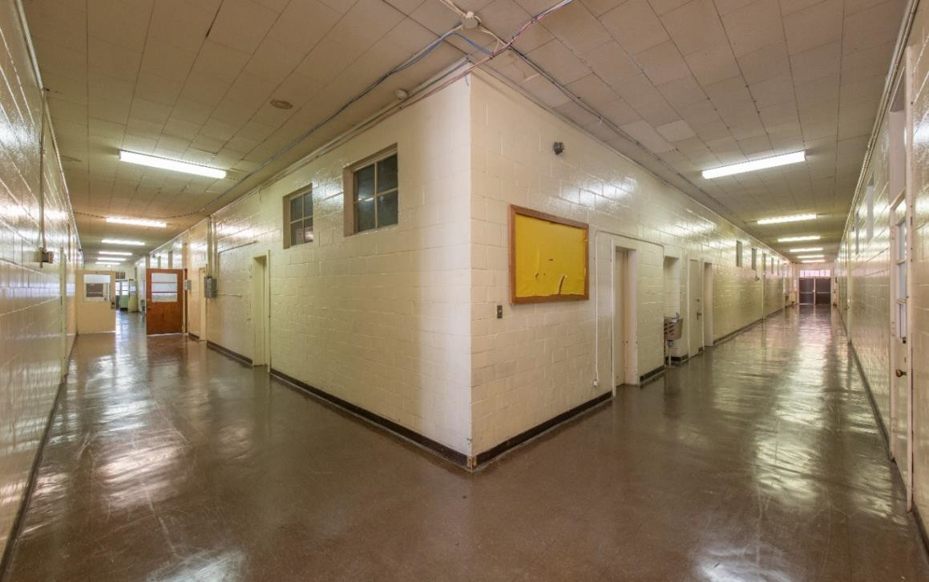
East-facing view of hallway (2021)
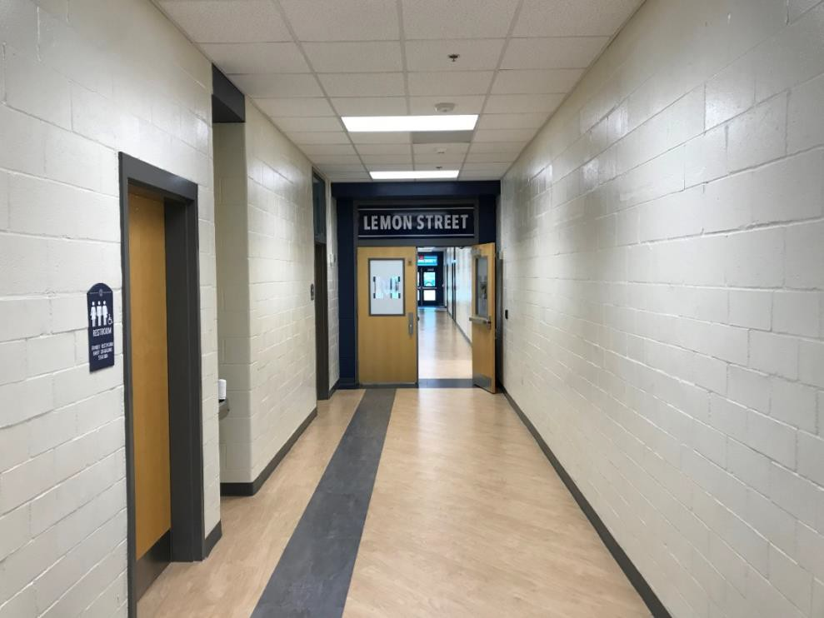

South-facing view of hallway (2021)
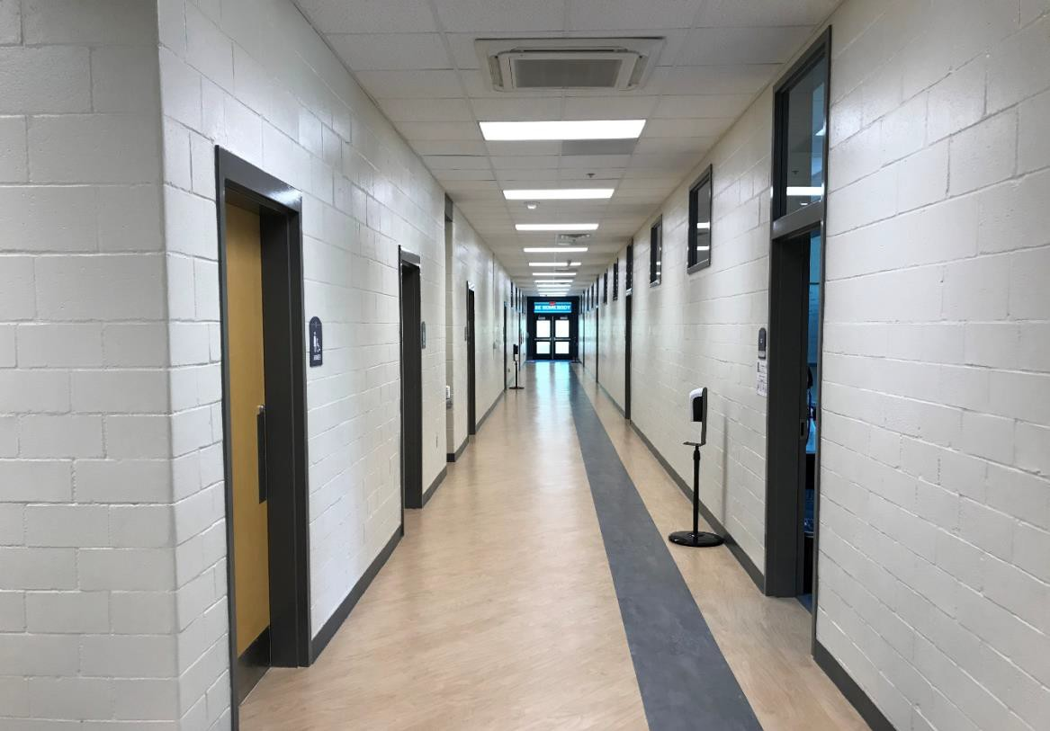
- – Classroom (2019)
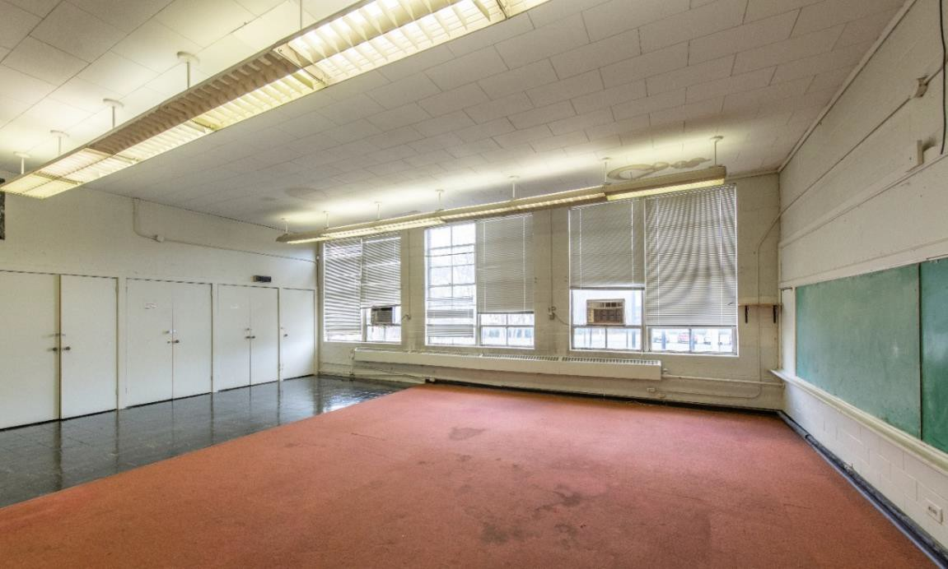

- – Classroom (2021)
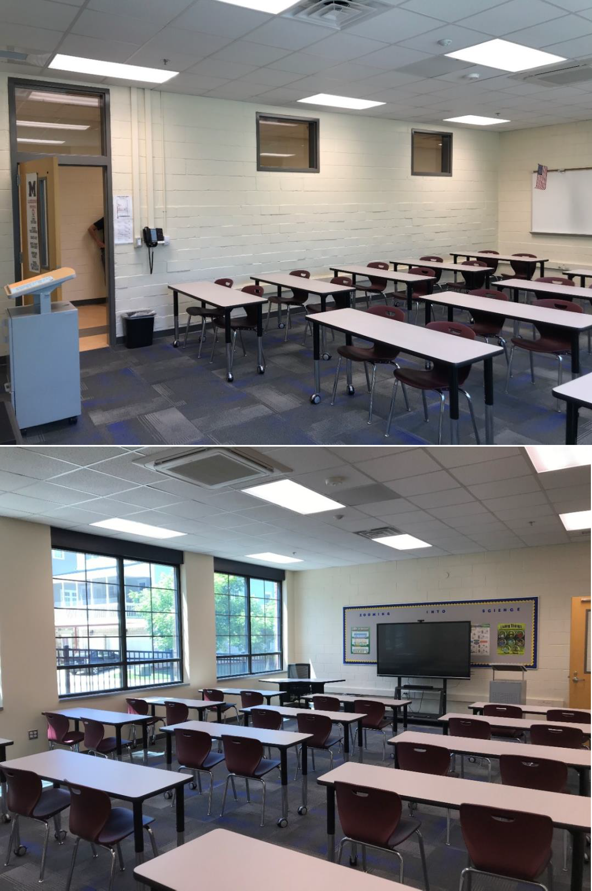

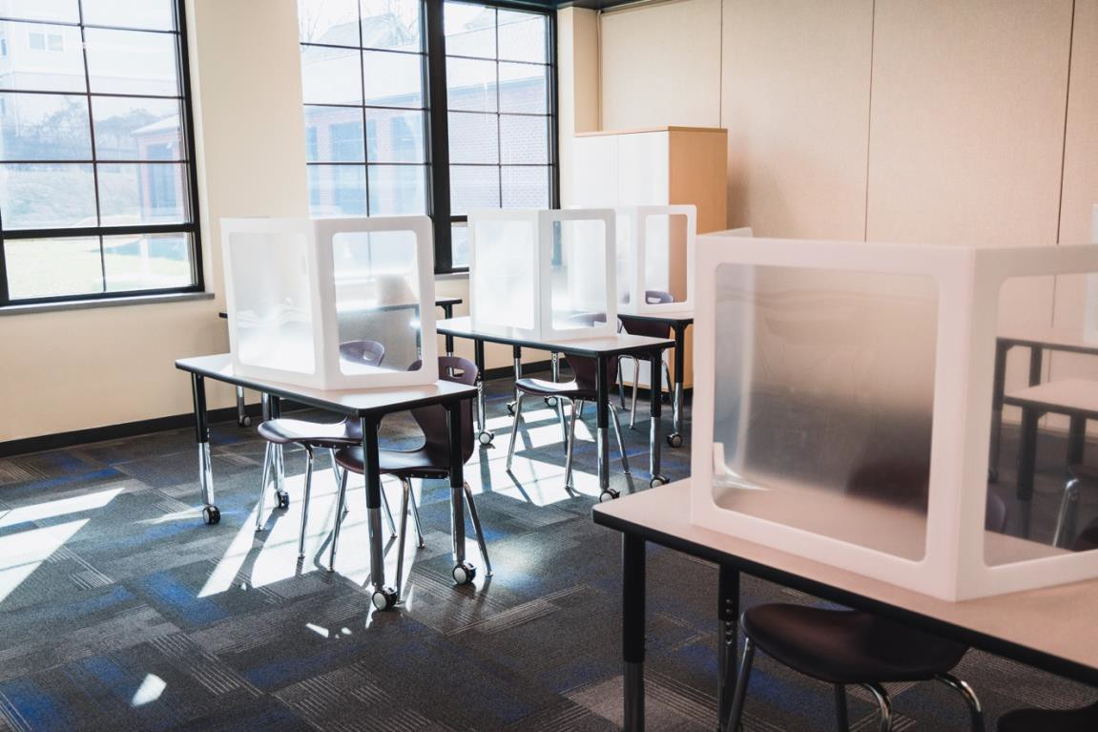
- – Classroom (2021)
- – Cafeteria (2021)
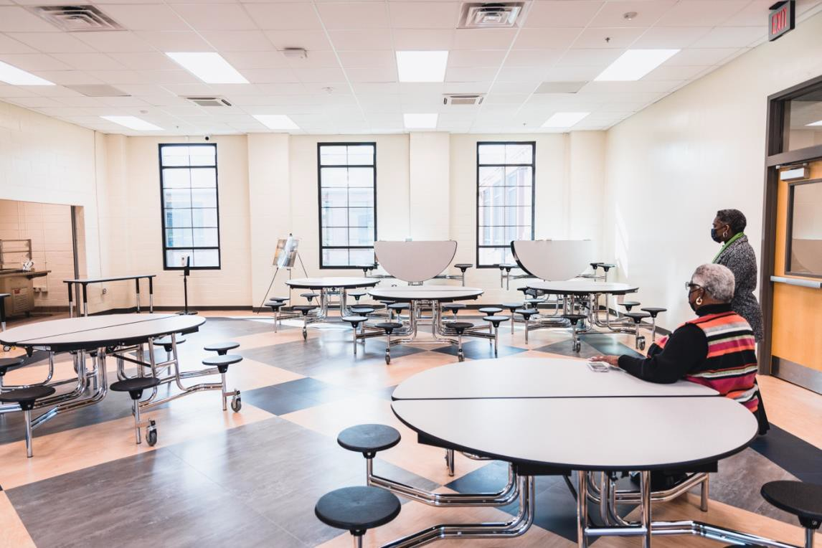

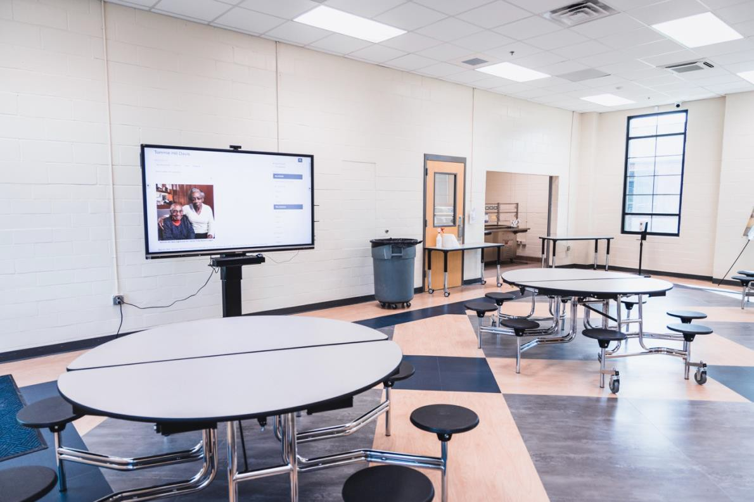

- – Kitchen (2021)
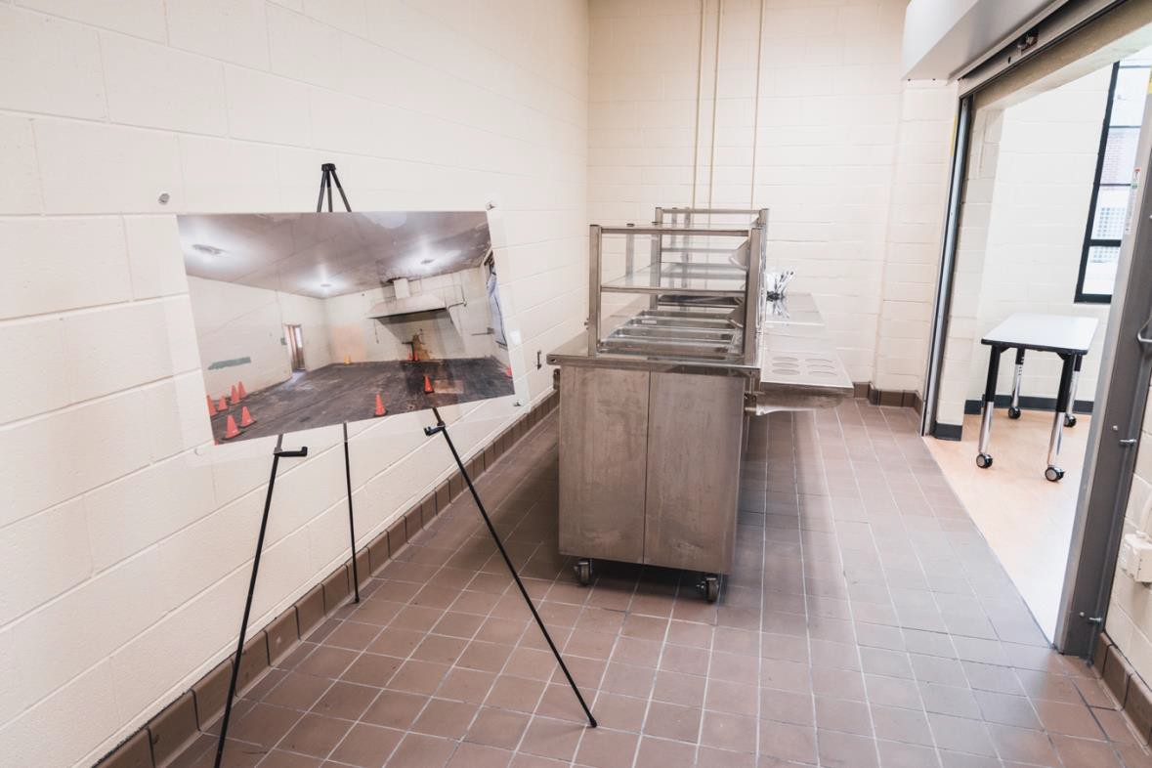

- – Science lab (2021, originally a basic classroom)
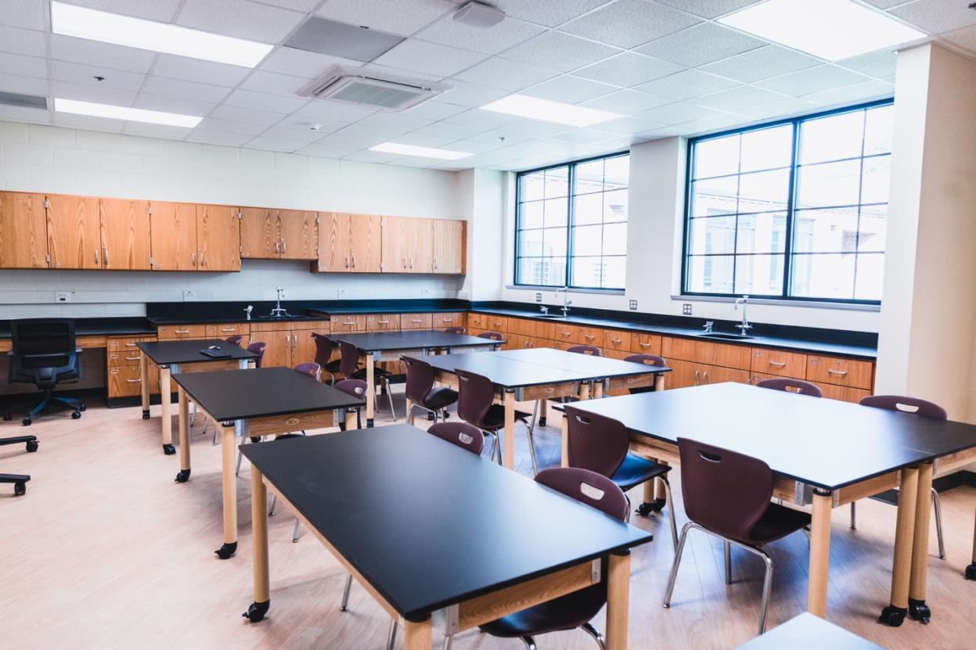

2021 Floor Plan
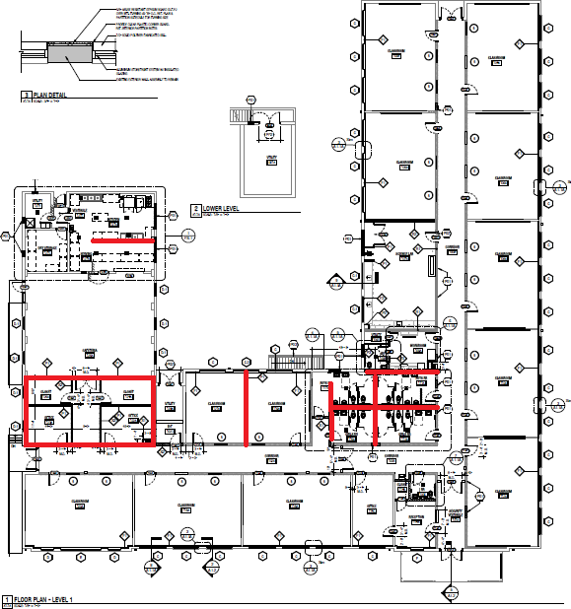

*Red lines denote wall changes made during the 2020-21 renovation, which also included the replacement of all doors and windows (aluminum), new plumbing and electrical systems, fire sprinklers and alarm systems, security systems, and the technology required for the school system to operate the building.

1951 Floor Plan
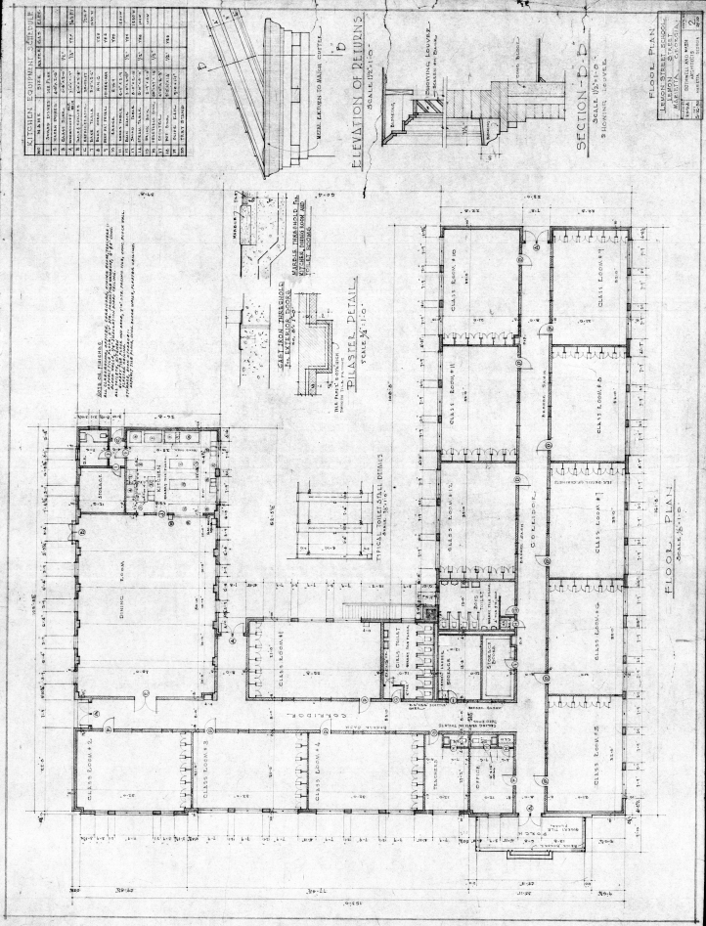

Site Plan
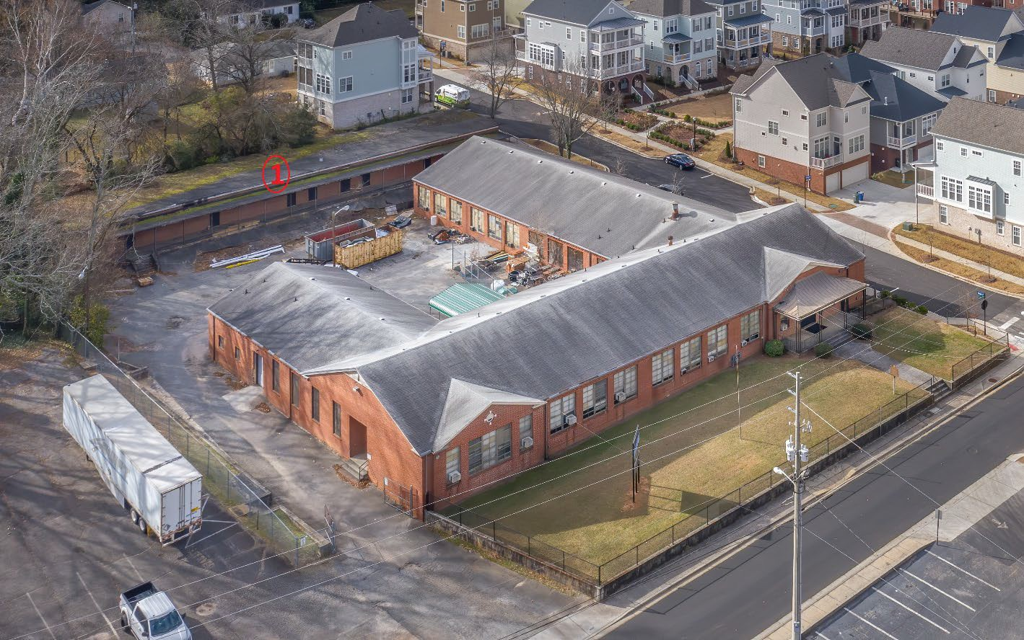
The building labeled 1 above is the annex constructed in 1955 to accommodate Lemon Street Elementary School’s growing number of students. The annex was demolished in 2020 at the start of the Lemon Street Elementary renovation.

Site plan continued
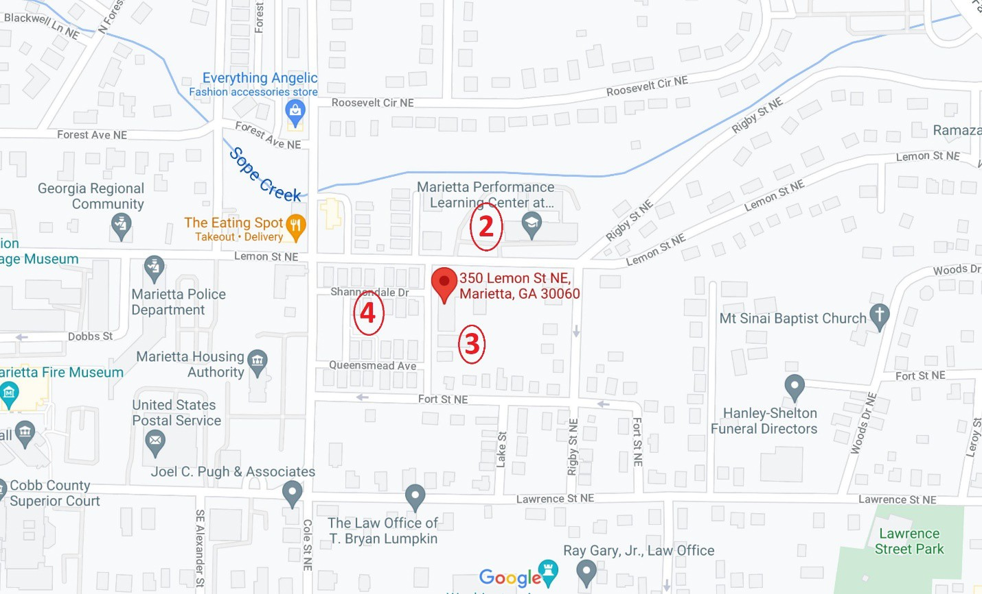
- – Site of the former Lemon Street High School (constructed 1930 with Rosenwald funds and named Marietta Industrial High School, later Perkinson High School, and finally Lemon Street High School in 1947-48), which was demolished after the 1967-68 school year, when all former students had transferred to Marietta High School following integration. The site will soon be home to the new Marietta City Schools central office building, which will closely resemble the former Lemon Street High School.
- – Site of the Lemon Street Elementary School annex (labeled 1 on the previous page).
- – Site of the former all-Black Fort Hill Homes public housing project constructed in 1941 and demolished in 2013. Built with similar architectural features to Fort Hill Homes, including iron work and brick detailing, Lemon Street Elementary School matched the adjacent housing project.

ion
350 Lemon St NE, Marietta, GA 30060

Forest Ave NE

Georgia Regional
Community
'

'
:ige Museum

+- Dobbs St
Marietta Police Department
Everything Angelic
Fashion accessories store
9

Fa,-E>
:Sf
-'tveNE
ub
Creek
The Eating Spot•
T
Takeout • Delivery
Lemon St NE

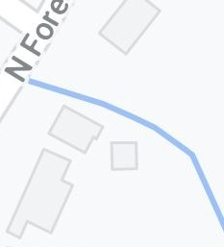
Roosevelt Cir NE

Shannondale Dr

Marietta Performance Learning Center at...

9

•

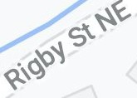 Ramaz
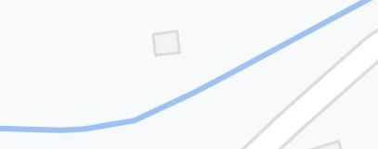
Lemon St NE
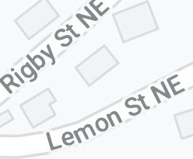
woods D
Mt Sinai Baptist Church
4'

Marietta Housing
:1rietta Fire Museum Authority T
'
Queensmead Ave
q Fort St NE

United States Postal Service
'
-+- Fort St NE

q q

en
QJ
-"
."..J'
+-
zw "T1
0
en
>-
z
.J:I
m
0,
Hanley-Shelton Funeral Directors

Cobb County Superior Court
Joel C. Pugh & Associates

en
ii:

Lawrence St NE

Lawrence St NE

m
)>
in
X
:0:>,
Q.
(")
0
in
z
m
The Law Office of
T. Bryan Lumpkin

Ray Gary, Jr., Law Office
9
Go gle(!J
Lawrence Street Park

Historic photographs
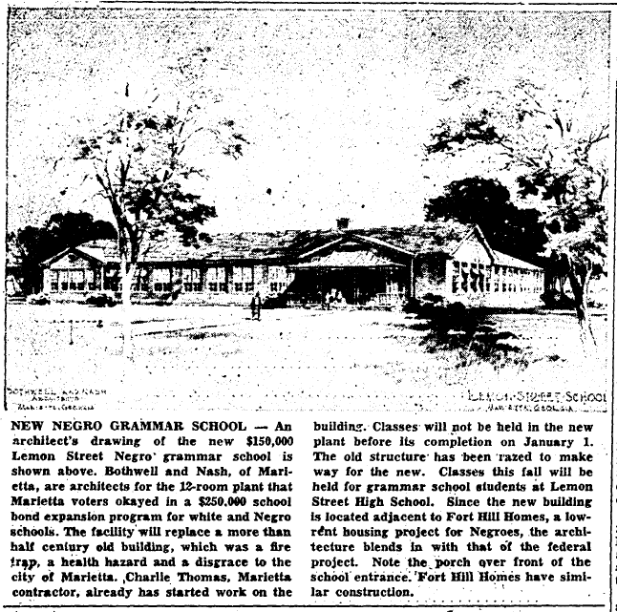
Marietta Daily Journal, July 13, 1950. Courtesy Marietta Daily Journal

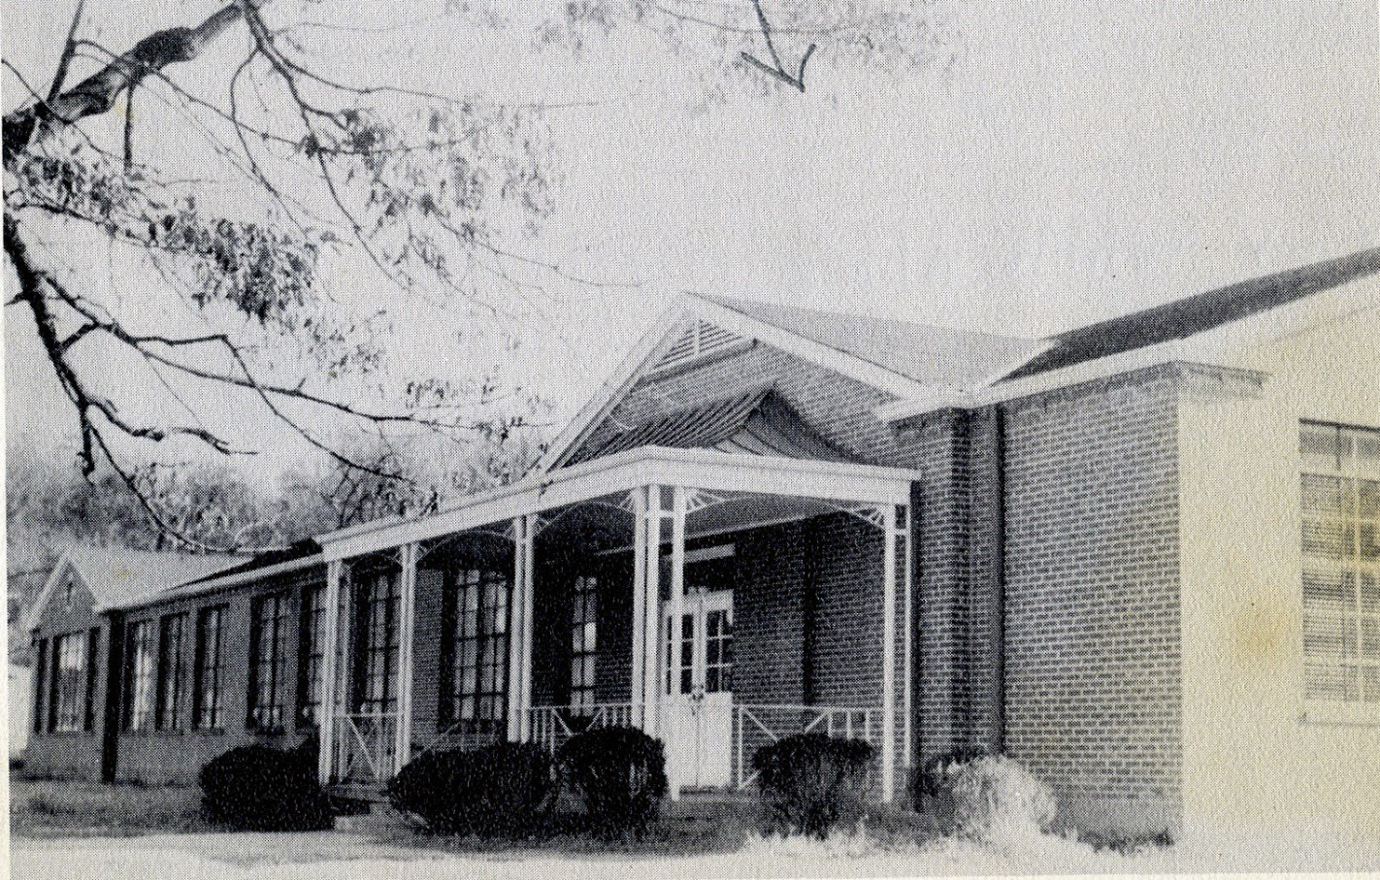

Lemon Street Elementary School in the 1953 Magnet, the annual yearbook produced by teachers and students at Lemon Street High School. Courtesy Marietta Museum of History

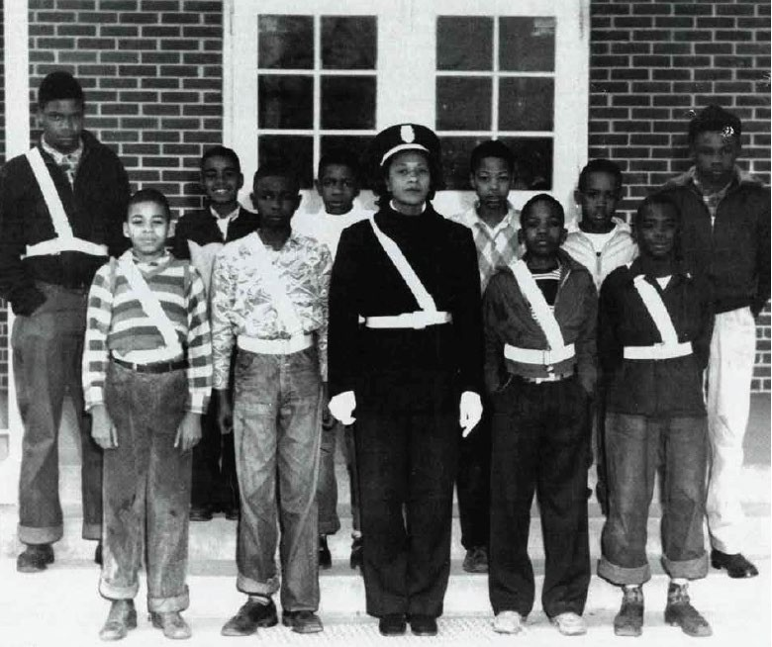

Edna Lockhart with student crossing guards in front of Lemon Street Elementary School, 1952. Courtesy Kennesaw State University Archives and Special Collections

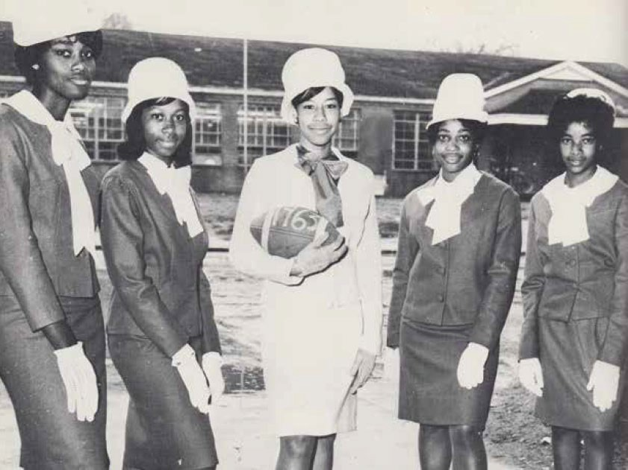

High school senior Ann Brown (center) as “Miss Lemon Street” with her attendants standing in front of Lemon Street Elementary School, 1964. Courtesy Kennesaw State University Archives and Special Collections

Children taking part in the federal Head Start program at Lemon Street Elementary School, 1965. Courtesy Kennesaw State University Archives and Special Collections

All contemporary photos are by:
- Natalie Roush, Marietta City Schools, Office of Communications
- James Newberry, Kennesaw State University, Department of Museums, Archives and Rare Books

